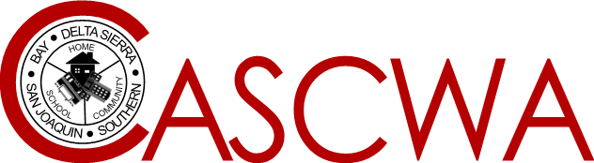
California Association of Supervisors of Child Welfare and Attendance

LEGISLATIVE UPDATE
October 2021

Prepared by Sherman Garnett
CASCWA Legislative Representative
Assisted by: A. Dosty and D. Martin

Listed below is a brief synopsis of current legislation that has been introduced in the state Assembly and Senate. Please note that each bill listed received legislative approval out of both the state Senate and Assembly and approved by the governor with implementation on Jan 1,2022 unless noted below. For a full description of each bill, you may access this information at: www.senate.ca.gov or www.assembly.ca.gov.

ASSEMBLY BILLS

AB 27 (Rivas)-Requires a LEA to administer a housing questionnaire for purposes of identifying homeless children and youth annually to all parents and guardians. Requires creation and posting on the web site the contact information of the liaison including resources available to persons experiencing homelessness.
AB 92 (Reyes) -Declares the intent of the legislature to enact legislation that would alleviate the burden on low-income families of fees for pre-school and childcare and developmental services.
AB 101 (Medina)-Adds the completion of a one-semester course in ethnic studies to the high school graduation requirements commencing with pupils graduating in the 2029-30 school year. Requires the course to be offered beginning in the 2025-2026 school year.
AB 104 (Gonzalez) - Requires an LEA to notify parents of their authority to request a pupil be retained in the pupil’s 2020-2021 grade level for the 2021-2022 school year with specific compliance to timelines .Would authorize a pupil who earned a letter grade in a course required for graduation from high school to change the letter grade to a “Pass or No Pass on the pupil’s transcript. Would require a LEA to exempt all pupils who during the 2020-2021 school year were in their 3rd or 4th year of high school that are in addition to the statewide coursework requirements. -Effective Immediately
AB 130- Budget Trailer Bill- Makes Wholesale Changes to Independent Study Rules and Regulations- -Chaptered- Note: Distance Learning Rules and Regulations have been replaced by Independent Study Regulations. – Effective Immediately.
AB 167- Budget Trailer Bill- Amends AB 130 to clarify Independent Study Regulations and Pass/No Pass Grade Change Requests.-Effective Immediately.
AB 309 (Gabriel)- Requires the California Department of Education to develop and post on the department’s web site mode student mental health protocols and procedures.
AB 367 (Garcia)- Would require a public school maintaining any combination of classes from grades 6-12 to stock in the school’s restrooms with an adequate supply of free menstrual products in all women’s restrooms and all-gender restrooms and in at least one men’s restroom at all times and to post a designated notice in each area before the start of the 2022-2023 school year.
AB 516 (Dahle)-Would include as an excused absence a student’s participation in a cultural ceremony or event.
(SENATE BILLS

SB 14 (Portantino)- Includes as another type of excused absence that is for the benefit of the mental or behavioral health of the pupil. Requires a LEA to certify on or before January 1,2023 that at least 50% of its certificated employees having directs contact with pupils at each school site or at least two classified and at least 2 certificated employees whichever is greater, having received the state department of education training related to mental and behavioral health.

SB 97 (Roth)- Requires on or after January 1,2023 for each LEA to make diabetes informational materials available to all parents and guardian when the pupil is first enrolled in elementary school and while the pupil is enrolled in grade 7.

SB 512(Min)- Expands current definition and age level of extended support to Foster Youth.

