California Association of Supervisors of Child Welfare and Attendance

San Joaquin Section

&

Stanislaus County Office of Education

School Attendance Review Board

**Attendance Certification and Mental Health Training**

Thursday, September 1, 2022 8:30 AM to 3:30 PM and

Friday, September 2, 2022 8:30 AM to 2:00 PM

Martin Petersen Event Center 720 12th St, Modesto California

*CASCWA is the only professional organization in the State of California for professionals*

*in the fields of "Child Welfare and Attendance."*

*The professional interaction that exists is more important today than it has ever been!*

**Thursday, September 1, 2022**

8:30 a.m. Welcome Messages

Sharma Uma, President CASCWA San Joaquin/SCOE SARB

* Scott Kuykendall, Stanislaus County Superintendent of Schools
* Jeff Dirkse Stanislaus County Sheriff
* Birgit Fladagar, Stanislaus County District Attorney
* Honorable Jeff Mangar, Stanislaus County Superior Court Judge
* Saundra Day, Educational Options/Special Ed. Assistant Superintendent
* Dalla Plaa, SCOE Prevention Director III
* Nancee Davis, SCOE Prevention Director II

8:40 a.m. **Becky Ray, Stanislaus County Office of Education, Alternative Education Teacher and Juvenile Court, Community, and Alternative School Administrators (JCCASAC) of California, Teacher of the Year for 2022!**

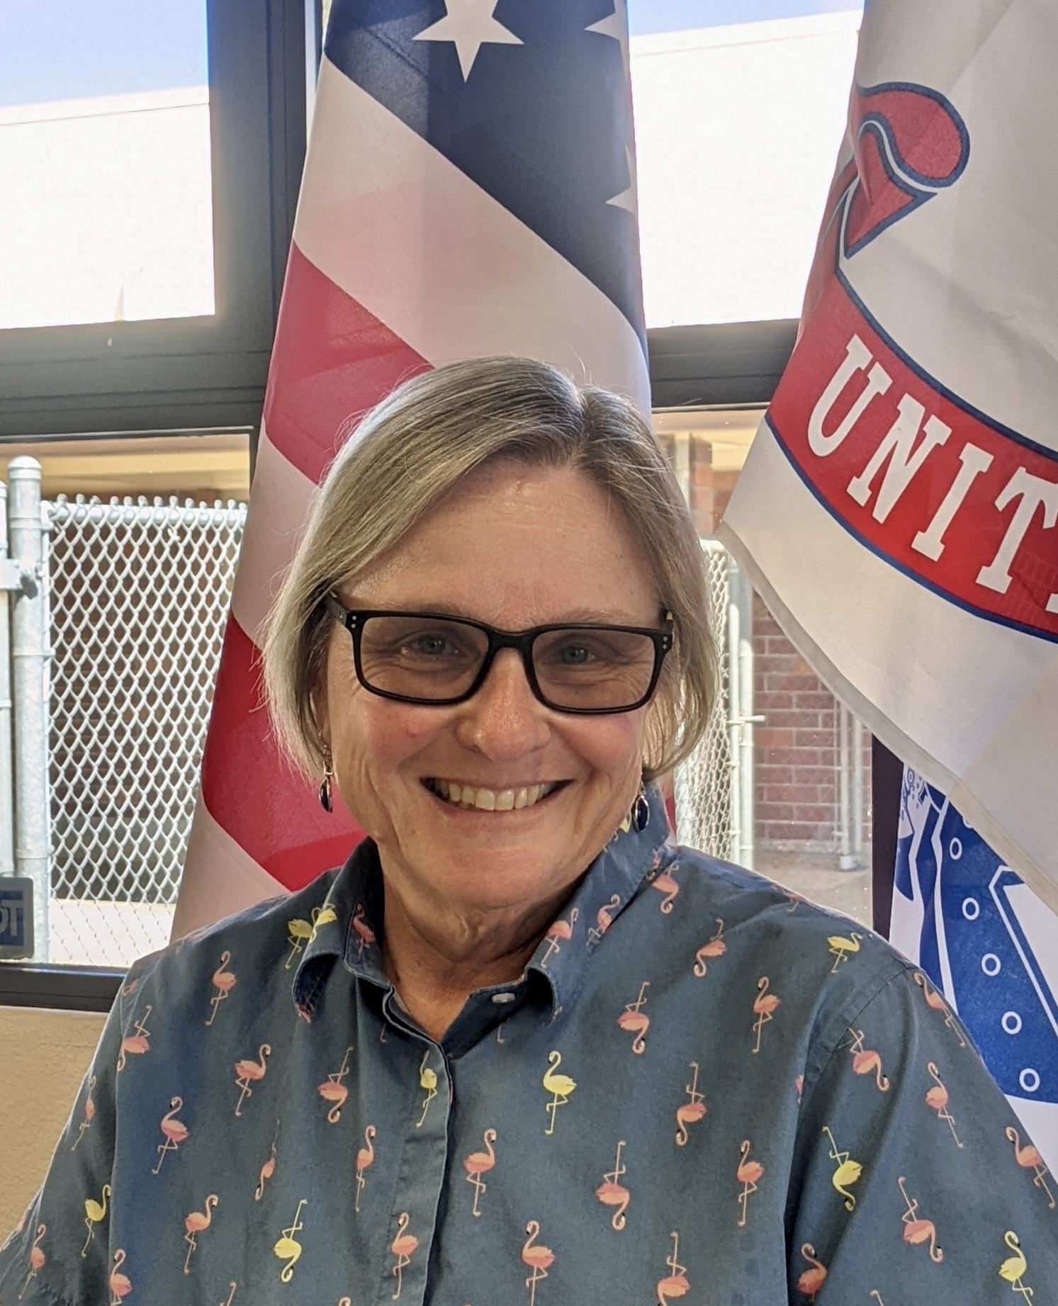

*Becky Ray truly embodies the character, heart, and commitment the Alternative Education world must possess for student success. Dedicated, confident, passionate, and invested are just a few of the words used by students and colleagues when describing her. Becky has been a teacher at the Stanislaus County Office of Education for over 34 years, engaging students in and beyond the classroom. Throughout her tenure with the Educational Options division, she has taught all subject areas in the classroom and is currently teaching modified Independent Studies.*

8:45 a.m. *A Moment for Yourself While Navigating Around Chaos*

Danielle Jones, Stanislaus County Office of Education, After School Planning Coordinator,

9:10 a.m. **The Three Elements of Self-Compassion!**

Jennifer Johnson, MSW, LCSW, California State University, Stanislaus Lecturer-Master of Social Work Program, PEER Project Coordinator

Utilizing the three themes of self-compassion can change our way of interacting not only with ourselves but also with the students and families we serve through the school system. Self-compassion is the most basic mental health strategy to roll out to all providers; teachers, administrators, case managers, school-based counselors, and classroom aides. The push for self-care was indeed warranted but unfortunately there is little long-term benefit to self-care practices unless a strong foundation of self- acceptance and self- worth is had - and that is where self- compassion comes in, it helps create such a foundation.

11:00 a.m. ***SART’s/DART’s and SARB to Help Get Your Kids in Their Seats -***

**Addressing Student Attendance – Maria Lobato, MCS SARB Coordinator, 25 years of experience at the Modesto City Schools.** She supervises attendance liaisons, coordinates, facilitates and conducts SARB meetings/hearings, SARTS, and refers SARB cases to Superior Court, appear and provide updates to the judge, perform home visits as necessary, provides trainings for Attendance Liaisons, provides guidance and assistance to all K-12 sites to assure the district’s attendance policies are implemented. Some of the many aspects of SARB also requires that other educational options are available. MCS SARB also provide information on alternative placements. Modesto City SARB Team is made up of SARB Coordinator, SARB Assistant and 5 Truancy/Attendance Liaisons who cover the entire school district of 30, 000 students. This session will focus on the importance of early attendance interventions, school and community resources, attendance liaisons responsibilities and impact and celebrating attendance improvements.

12:00 p.m. Lunch

12:30 p.m. **Restorative Restart: Addressing Attendance Habits in a Post-Pandemic World, SCHOOL INNOVATIONS & ACHIEVEMENT SI&A**

Abstract: “The willingness to show up changes us, it makes us a little braver each time. Bravery is the choice to show up and listen to another person, be it a loved one or perceived foe, even when it is uncomfortable, painful, or the last thing you want to do.” –Brene Brown

As students and staff return to schools this session will explore the necessary strategies to reinforce student, and parent, habits on daily attendance.  Real world examples and options to bring students back into the school culture after two and half years of disrupted program offerings.

Presenters: Brenda Tapp, School innovations & Achievement; Jose Beltran, Ceres USDSCHOOL INNOVATIONS & ACHIEVEMENT   
*Makers of Award-Winning Software & Service* 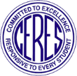

1:30-2:00 **The “New” 988 Suicide & Crisis Lifeline**

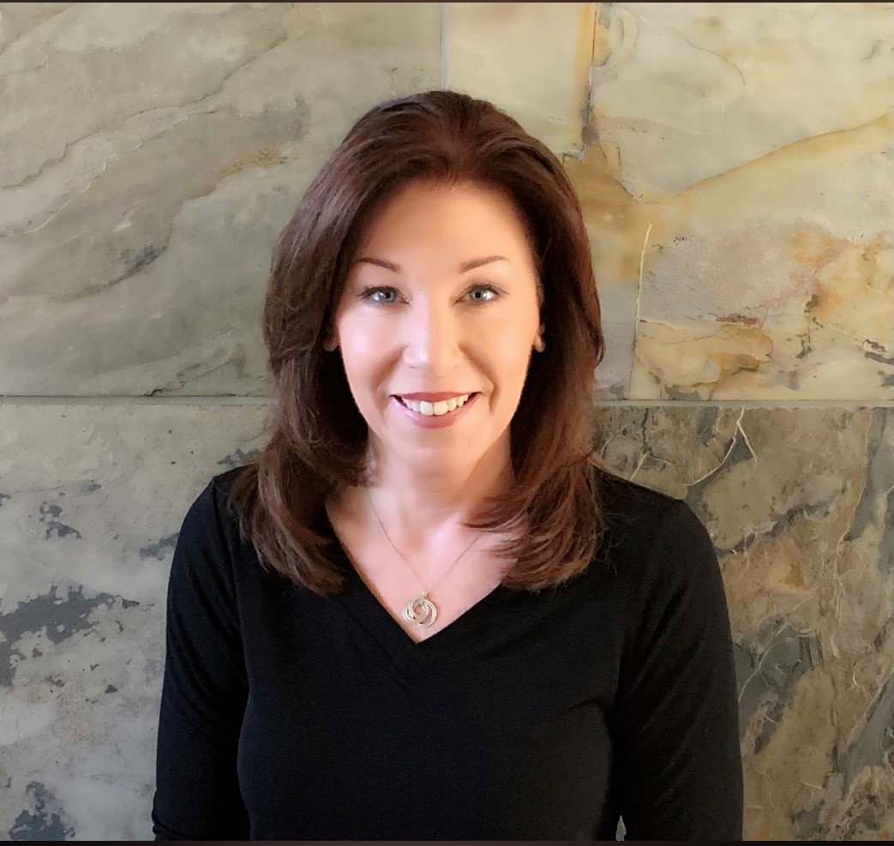

Join Jennifer Baker, M.A., M.A. Ed., LMFT who will share information and updates on the new 988 Suicide & Crisis Lifeline, which in 2020 Congress designated would operate through the existing National Suicide Prevention Lifeline. The 988 Suicide & Crisis Lifeline went live on July 16, 2022, providing free and confidential support for anyone experiencing a suicidal, mental health, and/or substance use crisis.

2:00 p.m. ***Legislative Updates and Attendance***

Dan Martin, State of California SARB Board

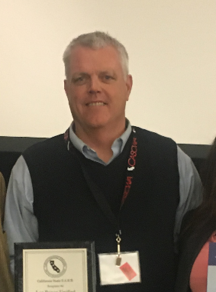

Coordinator of Child Welfare and Attendance at Los Banos Unified School District in the central Valley, which serves a very diverse population. Starting his 36th year as an educator, promoting and helping the community he was born and raised in. Over those 36 years of experience, Dan has had a variety of roles from teaching at-promise students in a self-contained classroom, athletic head coach, dean of students, and principal of a comprehensive high school of 2500 students. Currently working with Sherman Garnett, and Allen Dosty, CASCWA Legislative Analysts who provide legislative updates in the State and with the CASCWA organization.

3:15 p.m. ***Engaging Middle School Youth on Campus***

Mike Baldwin, Community Advocate

A Modesto resident since November 2018, Mr. Baldwin’s long, courageous journey toward purpose and a commitment to helping others is a testament to the resiliency of the human spirit in the face of immeasurable pain and tragic mistakes. His is an often-searing story, honestly told…………. “I was born in the city of Chicago, on the west side,” he recalled during an interview the other day…. Mr. Baldwin will share his past and his current work as a community advocate (…he began to help other men get free) and a paralegal since his move to Modesto in 2018. He is currently assisting our Middle School students.

**4:30 p.m. – 5:30 p.m. Networking Session**

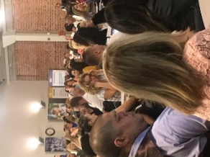  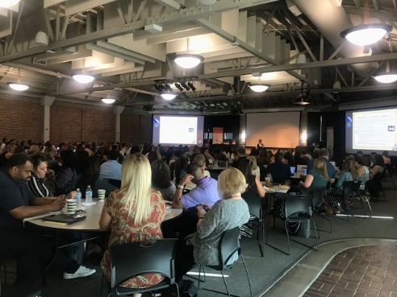

[This Photo](https://yournorthcounty.com/business-networking-groups-san-diego-north-county/) by Unknown Author is licensed under [CC BY](https://creativecommons.org/licenses/by/3.0/)

**Friday, September 2, 2022**

8:30 a.m. ***Stanislaus County Office of Education, Career Inspiration Center***

**Dallas Plaa, Stanislaus County Office of Education, Prevention Programs Director III**

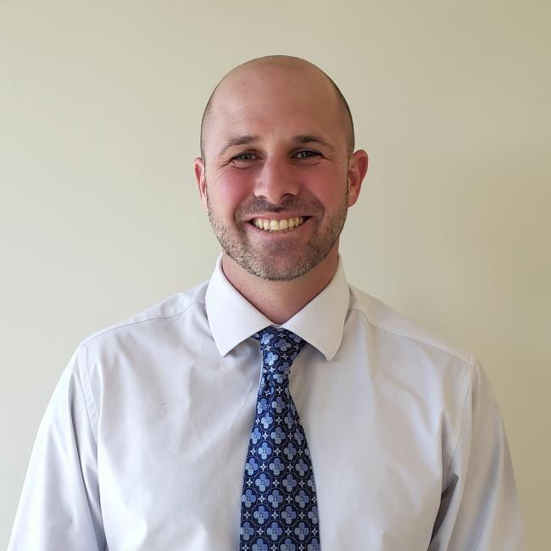

*The Career Inspiration Center is an exciting and innovative program that includes hands-on learning and career pathway awareness opportunities for Stanislaus County 7th-12th graders of partnering school districts, which include Ceres, Denair, Hughson, and Patterson,* Sylvan, Waterford, Keyes, Hickman, Salida, and Riverbank.

*“*Students who participate in the program will also have access to additional resources and program offerings which may include summer workshops, field trips to businesses, educational programs, internships, industry-recognized certifications, and an end-of-year culminating activity.”

9:00 a.m. Building a Positive School Culture For All Students, **Shaun Hurtado, Modesto City Schools, La Loma Middle School Principal**

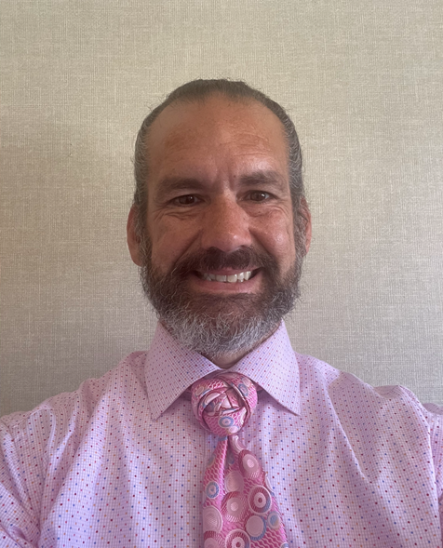

*Shaun Hurtado has served in leadership and educator roles in urban, rural and suburban school districts. His experience and professional passions include creating positive school cultures for all students and staff, creating the conditions so people can thrive in their careers improving learning outcomes for all students and cultivating leadership in others. Additionally, he has presented at local and state conferences as well as facilitated leadership and coaching development sessions on Student Mental Health, incorporating Restorative Practices, building a positive school culture and cultivating leadership in others. Mr. Hurtado is passionate about his role as an instructional and transformational leader. He feels he can have a lasting, positive impact on his community by educating youth, being a positive role model, and providing consistent leadership for students, teachers, community members, and other stakeholders.*

10:00 a.m. ***Connecting with Students on Campus through the PHAST Program & Current Drug Trends***

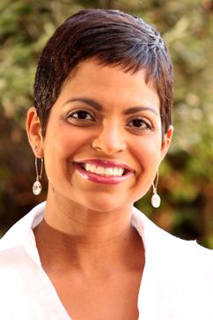

**Charmaine Monte, SCOE TUPE Coordinator**

**Elizabeth Escalante, SCOE, TUPE Coordinator**

*Charmaine and Elizabeth are experts in the TUPE/PHAST program and will share their expertise on empowering youth by using their own voice* ensures lasting change in our community and creates the next generation of nicotine-free advocates.

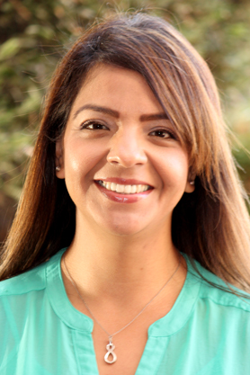

10:55 a.m. Break

11:00 a.m. ***Increasing Cognitive Attention in Any Class***

**Erin Dolin, EdD, Clovis Community College, Occupational Therapy Assistant Program Director**

*Dr. Dolin is an expert in behavioral interventions and using the neuroscience of movement in classrooms to increase attention and engagement for increased academic performance and reduction of behavior problems. Her techniques and strategies are complementary to classroom and school wide efforts to increase learning, reduce disruptive behavior, and support SWPBIS and SEL programs. As an occupational therapist she has a unique perspective to learning and behavioral interventions. This session will provide strategies that any teacher or administrator can use to change a classroom. You will receive new strategies to help support teachers and increase classroom management for all students.*

12:00 p.m. **Closing with Lunch on the Go!**

**SAVE THE DATE​**

CASCWA State Conference

**"Practitioners Learning from Practitioners"**

School Climate | Attendance | SEL | Drug Education

May 10-12, 2023

DoubleTree by Hilton Hotel and Conference Center

Call For Presenters

2023 State Conference!

May 10-12, 2023

Double Tree by

Hilton

Fresno Ca

<https://www.surveymonkey.com/r/HZQ7C9Y>

The complexity of challenges that our students, families, and districts are facing require that educational agencies provide services working in a tiered approach to ensure all students’ needs are being addressed. Research has demonstrated significant positive outcomes of this approach for our students and families. The purpose of the state CASCWA conference, focusing through a Multi-Tiered lens, is to provide solutions to the current challenges schools, districts and county offices face in meeting the needs of each student and in expressing these efforts in their LCAP goals. Specific areas of interest include, but are not limited to, school climate, chronic absenteeism, truancy, school wide positive behavioral interventions and systems, universal design for learning, social emotional learning, and equity issues.  We are also including Student Services "Nuts & Bolts" sessions to ensure schools personnel are following the legal requirements in all areas of students supports.

Please make sure to include all of the information.  Please submit proposals as soon as possible as notifications for selection have begun and presentation time slots are filling quickly. Top of Form