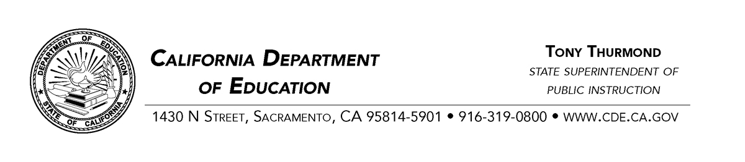
January 3, 2019
To: Youth interested in improving the lives of youth you many never meet who live throughout California.
On January 14, 2019, I would like you to join me in presenting a workshop in Woodland, CA. The workshop is called, Listen to the Wisdom of Youth: What Supports or Undermines Resiliency. The key is to build an understanding of how to help youth keep going in the face of challenges – and to stop creating barriers to their success.
In this workshop, I will ask questions (see the column on the left side of the attached page) to a panel of youth to lead them in an open discussion about issues that support or undermine their feelings of being welcome and being successful in school. The members of the youth panel respond to each question as they feel they have something to add, until the panel is ready to move on to the next question.
I am not looking for just easy and comfortable answers. The youth are there to help the educators in the audience understand about what youth consider to be uncomfortable challenges that they face, often on a daily basis, as well as the types of powerful supports educators and other adults can provide for the youth.
In my workshop introduction, I always tell adults in the audience that this is their opportunity to listen to and learn from the wisdom of youth, and that the adults are there to actively participate by simply listening, without splitting their concentration on forming and asking questions or planning how to present their own responses. After the panel is done, the audience can think about, and if time allows, discuss among themselves, how they will be taking back the wisdom they just received from the youth panel, and what changes they intend to make in their interactions with youth in their own programs (see the right side of the attachment). I like to have youth on the panel who have faced challenges, to remind the listeners that these youth often have some very wise things to say, if we will respect them and listen with an open mind.
The workshop will be part of the Yolo County Office of Education Tobacco-Use Prevention Education (TUPE) Summit – although tobacco and related substances are only one of the several topics being discussed (see the attached flyer for the event). It will be located at the Yolo County Office of Education, 1280 Santa Anita Court, Suite 120, Woodland, CA 95776. Our workshop is scheduled for 1:15 p.m. to 2:30 p.m. (come earlier for lunch).
I have been fortunate to present this workshop for many years at events throughout California. Each time, the youth tell me that they feel stronger for having spoken and been heard. I hope you can join me, contribute your wisdom, and experience this yourself.
Sincerely,
Dan Sackheim
Educational Options Office
California Department of Education
1430 N Street, Suite 4202
Sacramento, CA 95814
Office: 916-445-5595
Cell: 916-436-6330

