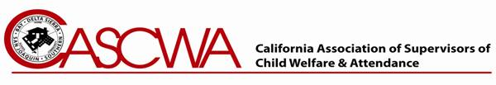

CASCWA Lee Lundberg Outstanding Service Award Recipients
Year | Recipient
2022 | Rick Riegel
2021 | Michelle Walsh
2020 | Brian Chandler
2019 | Jeni Mendel
2018 | Griselda Cardenas
2017 | Tim Catlin
2016 | Maria Hwang de Bravo
2015 | Alan Del Simone
2014 | David Kopperud
2013 | Rickey Jones
2012 | Benita Washington
2011 | Betty Folsom
2010 | Sherri Hanna
2009 | Jan Treff
2008 | Tom Mangione
2007 | Dennis Wiechmann
2006 | Debbie Morris
2005 | Sherman Garnett and Joe Taylor
2004 | Jerry Hime
2003 | Tad Kitada
2002 | Frank Boehler
2001 | Rob Gerig
2000 | Joe Brucia
1999 | Bob Brazil
1998 | Jack Erickson
1997 | Phil Kauble
1996 | (CASCWA State Award Named in Honor of Lee Lundberg)
1996 | Chris Mizzani
1995 | Lillie Wilson
1994 | Bill Booth
1993 | Jean Stovall
1992 | Milt Dooley
1991 | John Burton
1990 | CASCWA Initiates Outstanding Service Award – “Golden Rule”
3/11/2021

