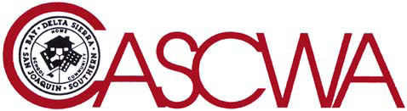
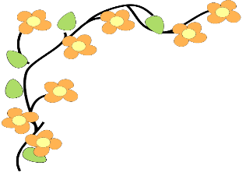

Bay Section California Association of Supervisors of Child Welfare and Attendance
– Spring Workshop–
Attendance Certification Training
&
CASCWA Student Scholarships
Friday, May 17, 2019 8 am- 3 pm
Alameda County Office of Education
313 W Winton Ave
Hayward, CA 94544

The Bay section of CASCWA will be hosting an attendance certification training. This certification will bring districts and their supervisors of attendance into alignment with Ed Code 48245 and Ed Code 48240. The training will cover:
- Chronic absence & truancy: promote awareness & intervention
- Attendance mandates & policies
- Excused vs unexcused absences-SART & SARB
- Data analysis and subgroups
- Disenrollment of truants
- Collaboration within school and with community agencies & partners
- Development of District and school wide strategies
- And much more

Audience: Supervisors of attendance, clerical staff, district and site administrator, intervention staff, anyone dealing with SART or SARB.

In addition, Bay Section will recognize our 2019 CASCWA Scholarship Winners!
Please join us in celebrating students who achieve despite obstacles and are on their way to college!

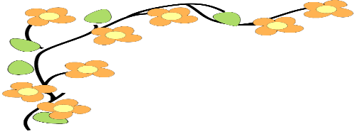
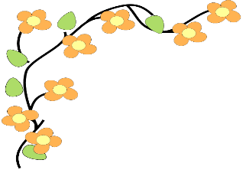

Bay Section California Association of Supervisors of Child Welfare and Attendance
– Spring Workshop–
Attendance Certification Training
&
CASCWA Student Scholarships
Friday, May 17, 2019 8 am- 3 pm
Alameda County Office of Education
313 W. Winton Ave
Hayward, CA 94544

Name: Title:

District/Agency/School:

Address: City: Zip:

Phone: Email:

Purchase Orders Accepted – P.O. Number:

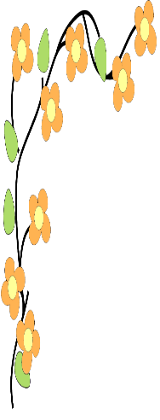
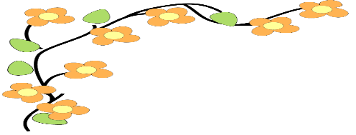
Registration Fee: $40.00 per Person (Includes Continental Breakfast and Lunch)
Checks payable to: Bay Section CASCWA

Scan and E-mail PO to: adelsimone@sbcglobal.net
Mail Registration and PO to:
Alan Del Simone
5116 Heavenly Ridge Lane
Richmond, CA 94803

Registration materials must be received by May 1, 2019

